Partial / residual correlation: USDCHF and EURGBP
Method 07 / daily log returns / leave-currency-out USD factor / Alpari D1 full available history

Study setup
Logical pair: USDCHF , EURGBP
Broker symbols: USDCHF_i , EURGBP_i
Snapshot: 2026-11-03_majors_alpari_D1
Timeframe: D1
Matched return window: 1999-01-06 to 2026-11-02 (UTC bar dates)
Matched return count n: 7129
Dropped unfinished last bar dated 2026-11-03 UTC after a tick-volume check against the prior complete day.
USD-strength sign rule: minus log return when USD is the quote (EURUSD, GBPUSD, AUDUSD, NZDUSD); plus log return when USD is the base (USDJPY, USDCHF, USDCAD). EURGBP is never a constituent.
Control z constituents (4): AUDUSD, NZDUSD, USDJPY, USDCAD
z_t = equal-weight mean of those USD-strength returns on the same day
Complete matched rows (Excel): USDCHF-EURGBP_Partial_D1.xlsx
Complete matched rows (HTML table): USDCHF-EURGBP_Partial_D1_data.html

Method carried forward
Partial / residual correlation regresses each matched daily log return of close, ln(close_t / close_t-1), on the same leave-currency-out USD strength factor z, then takes Pearson correlation of the two residual series. Quotes are not inverted. z is the equal-weight mean of USD-strength returns from other majors that do not share a non-USD currency with either leg; EURGBP is never a constituent. USD-strength is minus the log return when USD is the quote (EURUSD, GBPUSD, AUDUSD, NZDUSD) and plus the log return when USD is the base (USDJPY, USDCHF, USDCAD). OLS uses an intercept on each leg. rho_partial is symmetric under swap of the two symbols. It describes leftover linear co-movement after removing linear z; it is not a cause, not a lead, and not a trading signal. Daily rows are not independent and residuals are estimated, so the two-sided p-value and Fisher interval are secondary. Same-sample raw Pearson r is a side check only.

Regression on z
leg | intercept_a_or_c | slope_b_or_d | R2
USDCHF | -6.927e-05 | 0.662028 | 0.24961276
EURGBP | 2.408e-05 | -0.07047185 | 0.00517446

Results
rho_partial: -0.334660
Two-sided p-value: 4.21218e-186
Approximate 95% Fisher interval: [-0.355115, -0.313885]
Same-sample raw Pearson r: -0.325087
rho_partial minus r: -0.009573

Conclusion
Over 7129 matched daily rows for USDCHF and EURGBP after removing a leave-currency-out USD factor built from 4 constituents, rho_partial is -0.3347 (negative, weak residual linear link in this sample). Approximate 95% Fisher interval: [-0.3551, -0.3139]. Same-sample raw Pearson r is -0.3251 (partial minus r = -0.0096). Leg R-squared on z: USDCHF=0.2496, EURGBP=0.0052. Two-sided p under the usual independent-pairs model is 4.212e-186; residuals are estimated and daily FX rows are linked, so treat p as secondary. This does not establish cause, lead-lag, or a lasting trading rule.

Charts
Daily closes
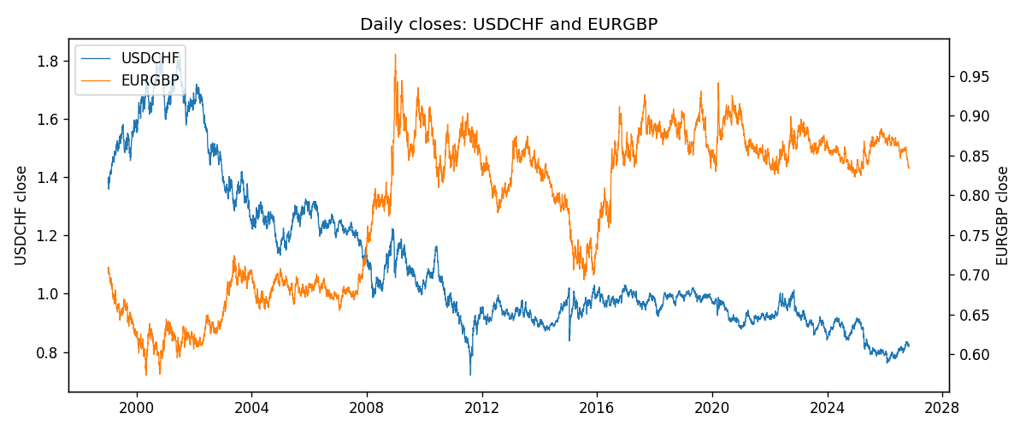
Log returns and control z
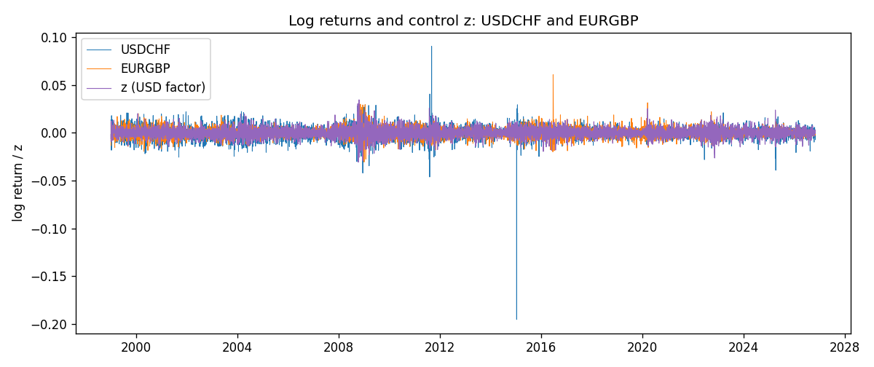
Residual scatter e_x vs e_y
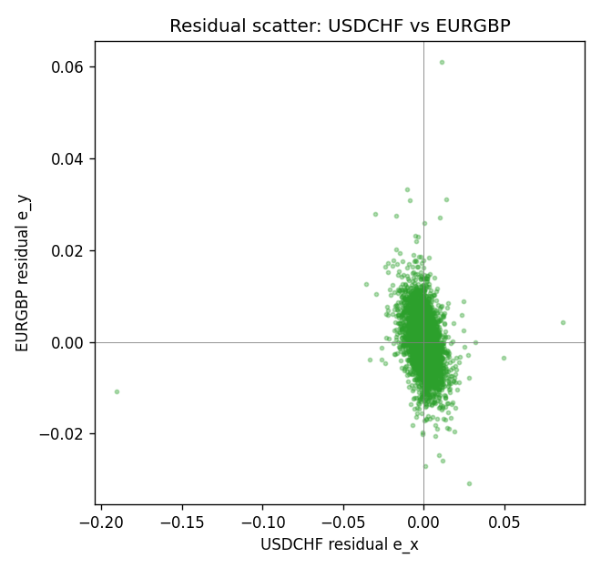

Data report
Every matched row that entered the partial correlation is stored in the sibling Excel workbook named USDCHF-EURGBP_Partial_D1.xlsx. That file is the complete data archive for redrawing charts. Embedding all rows as a Word table is impractical at this length; the Word file holds the column list, column summaries, and the first and last 15 matched rows.
Columns: time, USDCHF_open, EURGBP_open, USDCHF_high, EURGBP_high, USDCHF_low, EURGBP_low, USDCHF_close, EURGBP_close, USDCHF_tick_volume, EURGBP_tick_volume, USDCHF_spread, EURGBP_spread, USDCHF_real_volume, EURGBP_real_volume, USDCHF_log_return, EURGBP_log_return, usd_strength_AUDUSD, usd_strength_NZDUSD, usd_strength_USDJPY, usd_strength_USDCAD, z, USDCHF_fitted, EURGBP_fitted, USDCHF_resid, EURGBP_resid
Column summaries (matched calculation rows)
column | count | mean | std | min | 25% | 50% | 75% | max
USDCHF_open | 7129 | 1.0951138 | 0.25118089 | 0.72022 | 0.92021 | 0.98922 | 1.2338 | 1.8219
EURGBP_open | 7129 | 0.78787915 | 0.09637748 | 0.5734 | 0.6884 | 0.83444 | 0.8655 | 0.9769
USDCHF_high | 7129 | 1.1003827 | 0.25290445 | 0.73305 | 0.92437 | 0.99277 | 1.2388 | 1.8313
EURGBP_high | 7129 | 0.79096121 | 0.09675282 | 0.5789 | 0.6905 | 0.83739 | 0.86841 | 0.9799
USDCHF_low | 7129 | 1.0900119 | 0.24960424 | 0.08565 | 0.91678 | 0.98569 | 1.2282 | 1.8121
EURGBP_low | 7129 | 0.78517685 | 0.09619509 | 0.5682 | 0.6863 | 0.83221 | 0.86303 | 0.9661
USDCHF_close | 7129 | 1.095104 | 0.2510738 | 0.72025 | 0.92042 | 0.98919 | 1.2338 | 1.8217
EURGBP_close | 7129 | 0.78792406 | 0.09637588 | 0.5735 | 0.6884 | 0.83444 | 0.86555 | 0.977
USDCHF_tick_volume | 7129 | 74839.647 | 113794.81 | 350 | 12927 | 40522 | 70774 | 858589
EURGBP_tick_volume | 7129 | 87747.814 | 145877.32 | 332 | 6718 | 44856 | 82002 | 1424684
USDCHF_spread | 7129 | 25.810212 | 24.608512 | 0 | 5 | 16 | 50 | 100
EURGBP_spread | 7129 | 21.135222 | 19.050893 | 0 | 4 | 13 | 40 | 50
USDCHF_real_volume | 7129 | 2.3471237e+10 | 8.9459287e+10 | 0 | 0 | 0 | 0 | 1.9331921e+12
EURGBP_real_volume | 7129 | 2.8078235e+10 | 1.3570431e+11 | 0 | 0 | 0 | 0 | 3.5726265e+12
USDCHF_log_return | 7129 | -7.228e-05 | 0.00659123 | -0.19545699 | -0.00334859 | 7.816e-05 | 0.00331593 | 0.09051364
EURGBP_log_return | 7129 | 2.44e-05 | 0.00487311 | -0.03067367 | -0.00262262 | -9.978e-05 | 0.00256826 | 0.06075387
usd_strength_AUDUSD | 7129 | -3.429e-05 | 0.00755471 | -0.0806166 | -0.004155 | -0.00029309 | 0.00384986 | 0.08602525
usd_strength_NZDUSD | 7129 | -2.603e-05 | 0.00764647 | -0.05966839 | -0.0045915 | -0.00024088 | 0.00423176 | 0.07027433
usd_strength_USDJPY | 7129 | 5.124e-05 | 0.0062132 | -0.03908203 | -0.00320044 | 0.00012446 | 0.00340927 | 0.05184024
usd_strength_USDCAD | 7129 | -9.1e-06 | 0.00514798 | -0.03859748 | -0.00283484 | 5.567e-05 | 0.00272835 | 0.03436319
z | 7129 | -4.54e-06 | 0.0049742 | -0.03078614 | -0.00289139 | -5.904e-05 | 0.00286391 | 0.03451983
USDCHF_fitted | 7129 | -7.228e-05 | 0.00329306 | -0.02045056 | -0.00198346 | -0.00010836 | 0.00182671 | 0.02278382
EURGBP_fitted | 7129 | 2.44e-05 | 0.00035054 | -0.00240859 | -0.00017774 | 2.824e-05 | 0.00022784 | 0.00219364
USDCHF_resid | 7129 | 0 | 0.00570964 | -0.19014905 | -0.00264015 | 0.00012106 | 0.00277258 | 0.08594531
EURGBP_resid | 7129 | 0 | 0.00486049 | -0.03079116 | -0.00268021 | -0.00012254 | 0.00254953 | 0.06099909
First 15 matched rows (selected columns)
time | USDCHF_close | EURGBP_close | USDCHF_log_return | EURGBP_log_return | z | USDCHF_fitted | EURGBP_fitted | USDCHF_resid | EURGBP_resid
1999-01-06 | 1.3912 | 0.7019 | 0.013605652 | -0.013303338 | -0.0016616431 | -0.001169329 | 0.0001411812 | 0.014774981 | -0.013444519
1999-01-07 | 1.3782 | 0.7097 | -0.0093883841 | 0.011051402 | -0.006623179 | -0.0044540047 | 0.00049082982 | -0.0049343794 | 0.010560572
1999-01-08 | 1.3935 | 0.7062 | 0.011040268 | -0.004943862 | -0.0016456757 | -0.0011587581 | 0.00014005595 | 0.012199026 | -0.005083918
1999-01-11 | 1.4009 | 0.7053 | 0.0052963193 | -0.0012752393 | -0.0093052516 | -0.0062296118 | 0.00067984044 | 0.011525931 | -0.0019550797
1999-01-12 | 1.3872 | 0.7077 | -0.0098275602 | 0.0033970309 | 0.012276608 | 0.0080581839 | -0.00084107317 | -0.017885744 | 0.004238104
1999-01-13 | 1.3621 | 0.708 | -0.018259701 | 0.00042381861 | 0.007635943 | 0.0049859335 | -0.0005140369 | -0.023245634 | 0.00093785551
1999-01-14 | 1.3588 | 0.7066 | -0.0024256692 | -0.0019793588 | 0.002455055 | 0.0015560405 | -0.00014893013 | -0.0039817096 | -0.0018304286
1999-01-15 | 1.3834 | 0.7012 | 0.01794228 | -0.0076715819 | -0.0016340965 | -0.0011510923 | 0.00013923994 | 0.019093372 | -0.0078108218
1999-01-18 | 1.379 | 0.7017 | -0.0031856384 | 0.00071280921 | 0.00049622364 | 0.00025923926 | -1.0887659e-05 | -0.0034448776 | 0.00072369687
1999-01-19 | 1.3789 | 0.7007 | -7.2518946e-05 | -0.0014261269 | -0.0029889291 | -0.0020480294 | 0.0002347175 | 0.0019755105 | -0.0016608444
1999-01-20 | 1.3889 | 0.7021 | 0.0072259871 | 0.0019960086 | -0.0041707075 | -0.0028303998 | 0.00031799961 | 0.010056387 | 0.001678009
1999-01-21 | 1.3836 | 0.7016 | -0.0038232689 | -0.00071240297 | -0.00016492828 | -0.00017846182 | 3.570494e-05 | -0.003644807 | -0.00074810791
1999-01-22 | 1.3834 | 0.7004 | -0.0001445609 | -0.0017118406 | 0.0082128655 | 0.0053678723 | -0.00055469369 | -0.0055124332 | -0.001157147
1999-01-25 | 1.3868 | 0.6966 | 0.0024546976 | -0.0054402425 | 0.00025148466 | 9.7215205e-05 | 6.3595494e-06 | 0.0023574824 | -0.005446602
1999-01-26 | 1.3897 | 0.6962 | 0.0020889617 | -0.00057438255 | -0.0015805793 | -0.0011156625 | 0.00013546849 | 0.0032046241 | -0.00070985104
Last 15 matched rows (selected columns)
time | USDCHF_close | EURGBP_close | USDCHF_log_return | EURGBP_log_return | z | USDCHF_fitted | EURGBP_fitted | USDCHF_resid | EURGBP_resid
2026-10-13 | 0.83244 | 0.84458 | -0.0024955621 | 0.00020130374 | -0.0036915589 | -0.00251319 | 0.00028423312 | 1.7627966e-05 | -8.2929385e-05
2026-10-14 | 0.83489 | 0.84553 | 0.0029388325 | 0.0011241873 | 0.0017110612 | 0.0010634958 | -9.6499513e-05 | 0.0018753367 | 0.0012206868
2026-10-15 | 0.82676 | 0.84479 | -0.0097855323 | -0.00087557391 | -0.00067034036 | -0.00051305877 | 7.1322264e-05 | -0.0092724735 | -0.00094689618
2026-10-16 | 0.82377 | 0.84307 | -0.0036230826 | -0.0020380844 | -0.0032381772 | -0.0022130387 | 0.00025228248 | -0.0014100439 | -0.0022903669
2026-10-19 | 0.82677 | 0.84259 | 0.0036351779 | -0.00056950988 | -0.0013416402 | -0.00095747808 | 0.00011863001 | 0.004592656 | -0.00068813989
2026-10-20 | 0.8246 | 0.83957 | -0.0026281224 | -0.0035906254 | -0.0032858105 | -0.0022445732 | 0.00025563928 | -0.00038354918 | -0.0038462647
2026-10-21 | 0.82427 | 0.83839 | -0.00040027413 | -0.00140647 | -0.0019686811 | -0.0013725967 | 0.00016281874 | 0.00097232258 | -0.0015692887
2026-10-22 | 0.82032 | 0.83682 | -0.0048036381 | -0.0018743924 | -0.0016635538 | -0.0011705939 | 0.00014131585 | -0.0036330442 | -0.0020157083
2026-10-23 | 0.82497 | 0.83751 | 0.005652514 | 0.00082421033 | -0.001272548 | -0.00091173709 | 0.00011376095 | 0.0065642511 | 0.00071044938
2026-10-26 | 0.82649 | 0.83762 | 0.0018407959 | 0.00013133309 | 0.0025709143 | 0.0016327426 | -0.00015709495 | 0.00020805335 | 0.00028842804
2026-10-27 | 0.82865 | 0.83595 | 0.0026100526 | -0.0019957343 | 0.00097503061 | 0.00057622289 | -4.4630072e-05 | 0.0020338297 | -0.0019511043
2026-10-28 | 0.82781 | 0.83651 | -0.0010142111 | 0.00066967224 | 0.00021052864 | 7.0101173e-05 | 9.2457959e-06 | -0.0010843123 | 0.00066042645
2026-10-29 | 0.82379 | 0.83553 | -0.0048680164 | -0.0011722209 | 0.00074371103 | 0.00042308285 | -2.8328554e-05 | -0.0052910992 | -0.0011438923
2026-10-30 | 0.82438 | 0.83351 | 0.00071594559 | -0.0024205543 | -0.000823784 | -0.00061464276 | 8.2135722e-05 | 0.0013305884 | -0.00250269
2026-11-02 | 0.81851 | 0.83426 | -0.0071459744 | 0.00089940465 | 0.0026934592 | 0.0017138708 | -0.00016573092 | -0.0088598452 | 0.0010651356

